Exploratory Data Analysis Report

Table of Contents
1. Introduction 3
2. Data Collection and Preparation 3
2.1 Summary of Data Collected 3
2.2 Data Cleaning and Preprocessing 3
3. Key Findings from EDA 4
3.1 Distributions and Descriptive Statistics 4
3.2 Sales Trends 5
3.3 Correlations and Store Performance 6
3.4 Outlier and Promotion Analysis 8
4. Data Validation Summary 9
5. Proposed Adjustments and Refinements 10
5.1 Adjustments to Analytics Approach 10
5.2 Refinements to Data Collection and Analysis 10
6. Code Review and Documentation 10
6.1 Review of Code Scripts 10
6.2 Documentation and Comments 11
References 11
Appendix A: Terminal Outputs 12
Appendix B: Code Screenshots 13

1. Introduction
The study provides an Exploratory Data Analysis (EDA) of a Walmart Retail Sales data, which includes three related tables: sales (421,570 rows), features (8,190 rows), and stores (45 rows). The dataset consists of weekly sales data of 45 stores in different departments (in total) between February 2010 and October 2012. Python libraries, including Pandas, NumPy, Matplotlib, Seaborn, and Scikit-learn were used in the analysis (McKinney, 2022). The aim is to verify the EDA pipeline, report on how they handled data quality and determine temporal and distributional trends.

2. Data Collection and Preparation

2.1 Summary of Data Collected
All the sales data (Store, Dept, Date, Weekly Sales, IsHoliday), features data (Store, Date, Temperature, Fuel Price, MarkDown15, CPI, Unemployment, IsHoliday) and stores data (Store, Type, Size) were loaded and joined to three CSV files. A left-join merge of the dataframes on Store, Date and IsHoliday resulted in a combined dataframe with 16 columns and 421,570 rows (Figure 1). The 45 shops can be divided into three categories: A (48. 9%), B (37. 8%), and C (13. 3%), covering 81 departments. The date range spans February 5, 2010, to October 26, 2012.
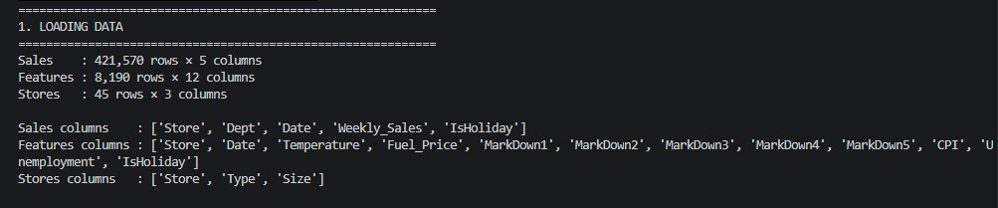
Figure 1: Data loading output – row counts and column names for all three datasets

2.2 Data Cleaning and Preprocessing
The date columns of both the sales and features databases were read using the dayfirst=True. In MarkDown1-5 the number of missing values per column was between 270,889 and 310,322 which were filled with 0 to represent the weeks on which no advertising campaign was in progress. Using forward-fill and back-fill, the NaN values of the rate of unemployment, and the CPI were fixed. It was shown that the median imputation technique injects 500 artificial NaNs into the column Weekly Sales and fills the column with the median. Outliers were dealt with by IQR x 3 capping: 12,877 and 13,756 Weekly Sales and Unemployment values were capped, respectively, but Temperature, Fuel_Price, and CPI did not have to be capped (Figure 2a, 2b). All the six quantitative variables had their Min-Max normalization and Z-score standardization.
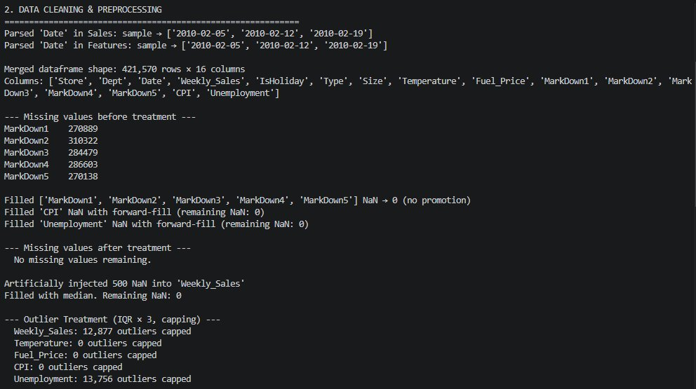
Figure 2a: Missing value counts, fill strategy output, and outlier capping summary
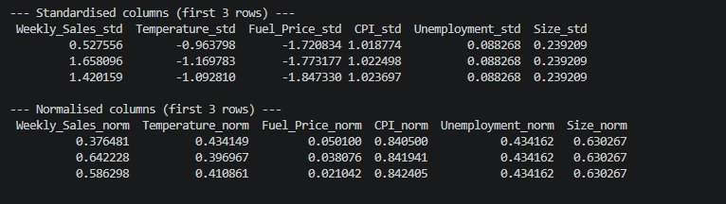
Figure 2b: Standardised and normalised column previews (first 3 rows)

3. Key Findings from EDA

3.1 Distributions and Descriptive Statistics
Weekly Sales is very skewed (skewness = +1). 738, kurtosis = +2. 372), as revealed by descriptive statistics with skewness and kurtosis which reveals that there are many low-value department-weeks along with a tail of high-revenue departments (Figure 3). Unemployment is skewed positively too ( +1 ). 046) which is equal to its range of 3. 879 to 13. 615. All the temperature, Fuel_Price, CPI and Size are approximately symmetrical. The bimodal forms of CPI and Size illustrated in the histogram and KDE overlays in Figure 4, are characteristics of various grouping of store size. The comparison of standardization (Figure 7) shows that the distributional form of Z-score rescaling does not impose any normality.
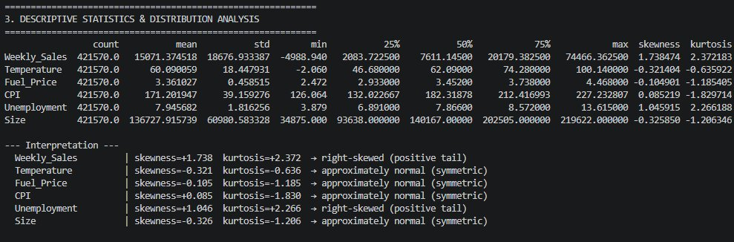
Figure 3: Descriptive statistics with skewness and kurtosis for all six numerical features
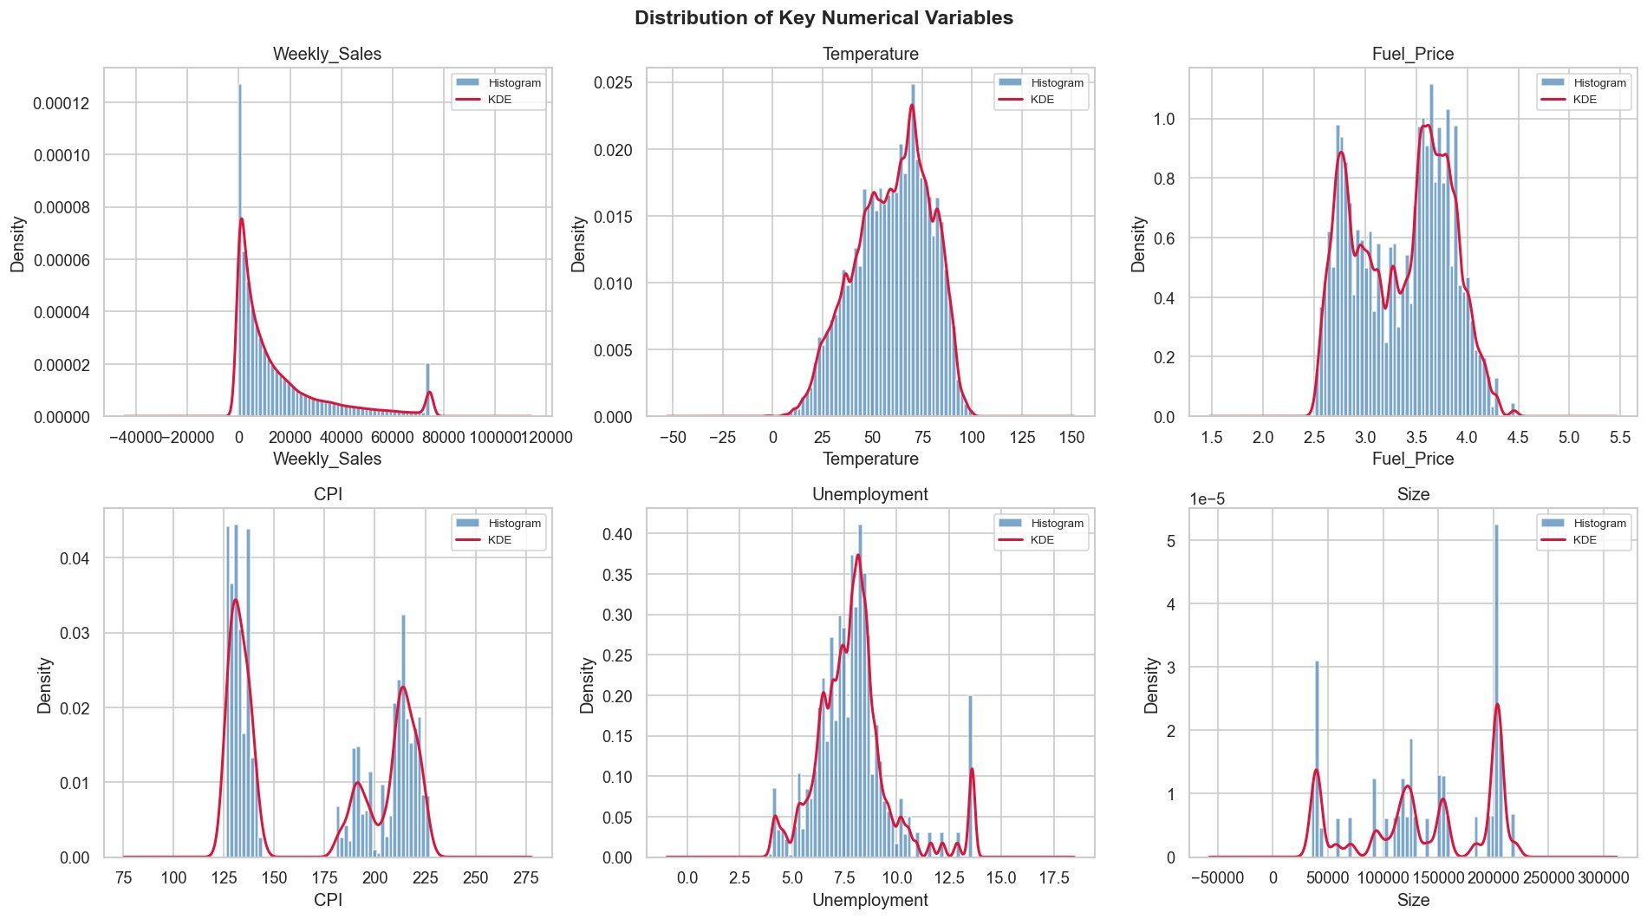
Figure 4: Histograms with KDE overlays for Weekly_Sales, Temperature, Fuel_Price, CPI, Unemployment, and Size

3.2 Sales Trends
Weekly Sales is very skewed (skewness = +1). 738, kurtosis = +2. 372), as revealed by descriptive statistics with skewness and kurtosis which reveals that there are many low-value department-weeks along with a tail of high-revenue departments (Figure 3). Unemployment is skewed positively too ( +1 ). 046) which is equal to its range of 3. 879 to 13. 615. All the temperature, Fuel_Price, CPI and Size are approximately symmetrical. The bimodal forms of CPI and Size illustrated in the histogram and KDE overlays in Figure 4, are characteristics of various grouping of store size. The comparison of standardization (Figure 7) shows that the distributional form of Z-score rescaling does not impose any normality.
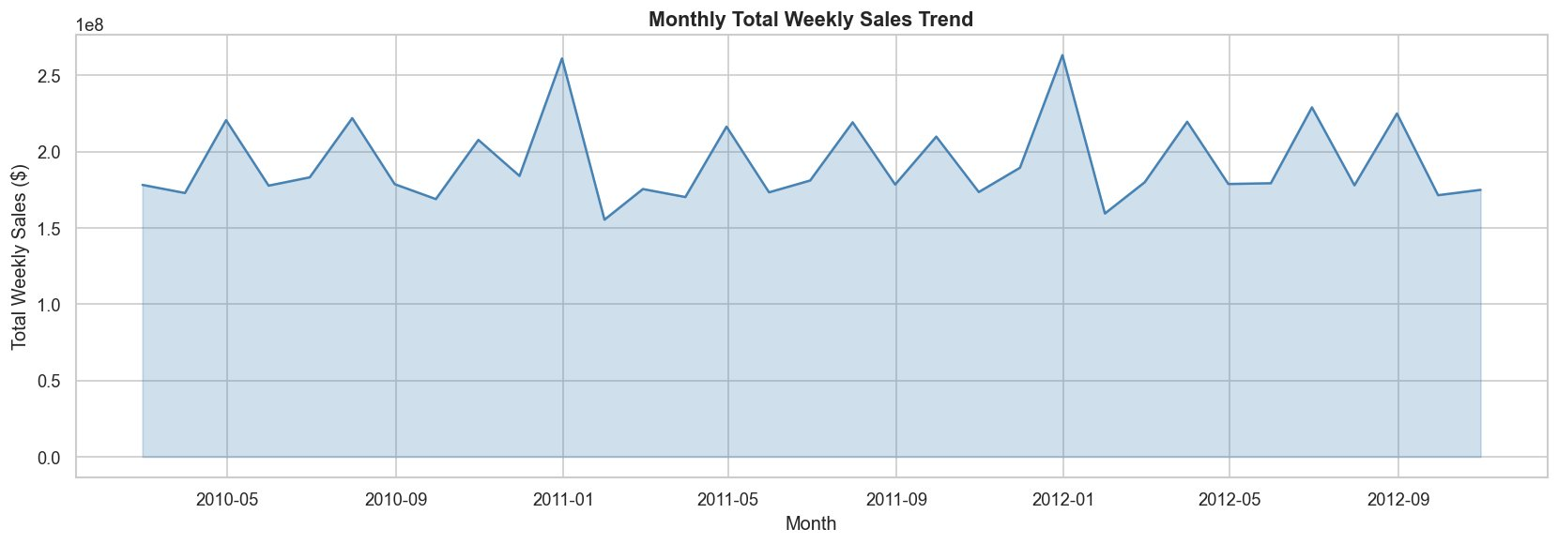
Figure 5: Monthly total weekly sales trend (Feb 2010 – Oct 2012) showing seasonal holiday spikes
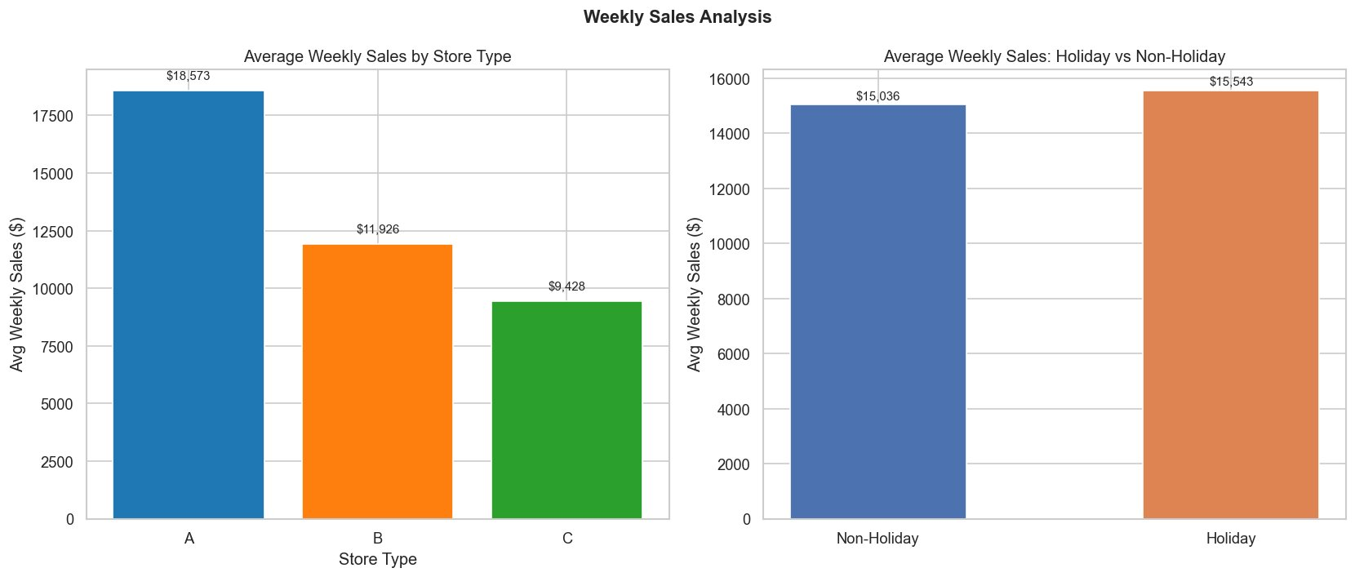
Figure 6: Average weekly sales by store type (left) and holiday vs non-holiday weeks (right)

3.3 Correlations and Store Performance
The heatmap of correlations (Figure 7) shows that Weekly_Sales is positively correlated with store size (r = 0.) the most. 26) which substantiates the conclusion that big stores generate more sales. There was a strong inter-promotion between MarkDown1 and MarkDown4 (r = 0. 84) suggests that such initiatives are usually done simultaneously. The correlation between CPI and unemployment is on the negative side, which is moderate (r = -0. 30). The weekly sales data does not have much direct correlation with any of the five MarkDown variables (r 0 ). 05). Store 4 has a total cumulative sales of approximately $ 265 million with store 20 coming behind with a sale of $ 260 million (Figure 8).
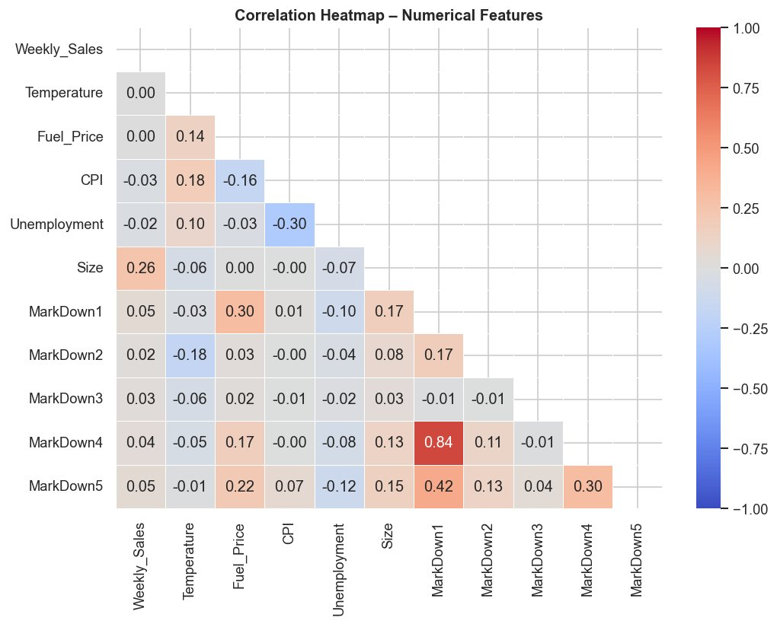
Figure 7: Correlation heatmap – Size–Weekly_Sales (r = 0.26); MarkDown1–MarkDown4 (r = 0.84)
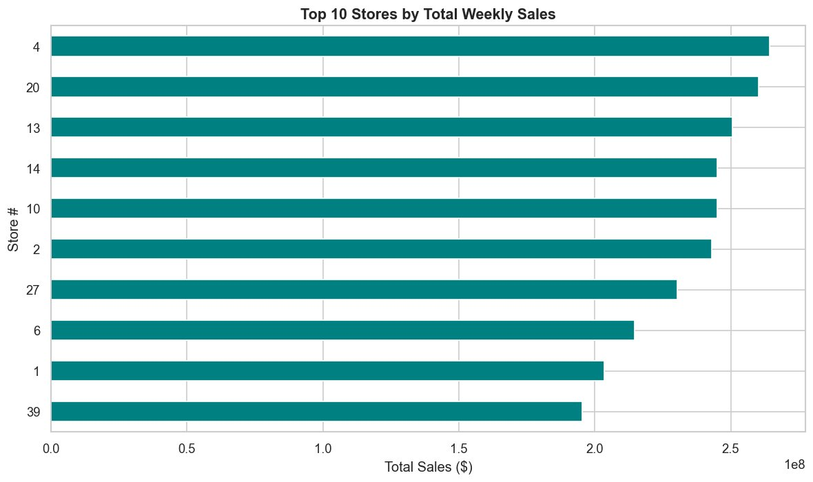
Figure 8: Top 10 stores by total weekly sales, led by Stores 4 and 20

3.4 Outlier and Promotion Analysis
The large interquartile range (approximately between $0 and $20,000) and the upper whisker (up to 75,000) in the boxplots (Figure 9) demonstrate that there is actual heterogeneity by department and type of store in terms of Weekly Sales. The Fuel_Price and Temperature distributions are small and symmetric. The small correlation coefficients observed can be justified by the MarkDown scatter plots (Figure 10) which indicate that each of the five promotional categories has a broad series of value of dollars, and is not linearly related to the weekly income.
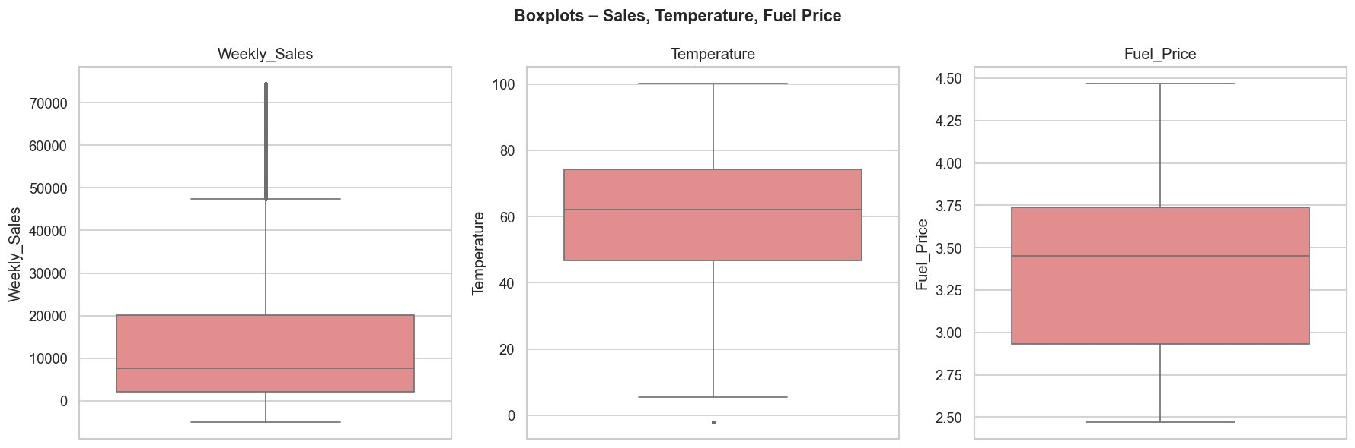
Figure 9: Boxplots for Weekly_Sales, Temperature, and Fuel_Price after IQR capping
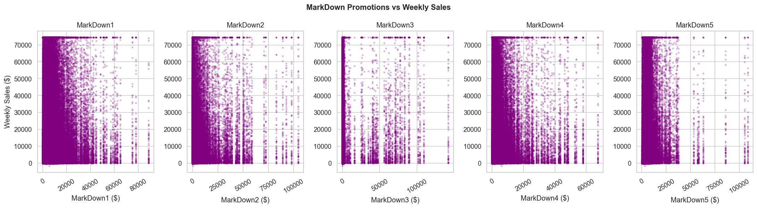
Figure 10: MarkDown promotion spend vs Weekly_Sales for all five markdown types

4. Data Validation Summary
Having no duplicated rows, and none of the remaining NaN values, the final dataset is 421,570 rows (Figure 11) in the final, cleaned and merged form. Under IQR capping, there are differences in weekly sales ranging between -4,988. 94 to $74,466. 36, with an average of $15,071. 37. The dataset includes 3 types of the stores (A, B, C), 81 departments and 45 different retail locations.
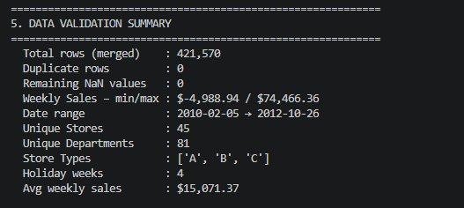
Figure 11: Data validation summary – zero NaN values, zero duplicates, sales min/max, and average
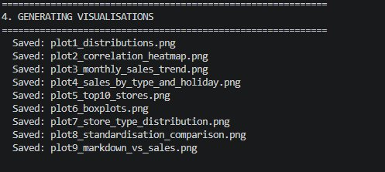
Figure 12: Visualisation output log confirming all nine plots saved successfully

5. Proposed Adjustments and Refinements

5.1 Adjustments to Analytics Approach
Since Weekly Sales has a skewness of +1.738 (right-skewed), it is suggested to use a transformation of log(x+1) before regression modelling to meet the normality (Field, 2018). The low MarkDown-to-sales correlations are indicative of lagged effects: it is possible that promotions can affect the sales in the following weeks but not immediately. The type of the stores will also be coded as dummy variables in predictive models because it is strongly related to revenue.

5.2 Refinements to Data Collection and Analysis
The IQR × 3 capping value is quite conservative, to determine the trade-off between outliers and information loss, sensitivity analysis, IQR × 1.5 and IQR × 2 is suggested (Tukey, 1977). Profitability analysis would be greatly enhanced by a unit cost or margin data, at most level departments, that would be available in place of aggregate weekly revenue.

6. Code Review and Documentation

6.1 Review of Code Scripts
The EDA script (superstoreeda.py) has five distinctly labeled sections that have console print separators. The entire transformations are based on vectorised Pandas and NumPy operations, without inefficient row-to-row iteration. numpy.random.seed(0) can be used to reproduce the synthetic NaN injection. The removeoutliers_iqr function can be reused and parameterised.

6.2 Documentation and Comments
The reason behind major decisions is provided in inline comments, e.g. why MarkDown NaN values are filled with a zero value, instead of the mean value. The names of the variables are in PEP 8 (Van Rossum et al., 2001). In order to make the codebase even better, a module-level docstring outlining inputs, outputs and dependencies of the library must be included.

References
Field, A. (2018). Discovering statistics using IBM SPSS statistics (5th ed.). SAGE Publications. https://uk.sagepub.com/en-gb/eur/discovering-statistics-using-ibm-spss-statistics/book257672
Géron, A. (2019). Hands-on machine learning with Scikit-Learn, Keras, and TensorFlow (2nd ed.). O’Reilly Media. https://www.oreilly.com/library/view/hands-on-machine-learning/9781492032632/
Hyndman, R. J., & Athanasopoulos, G. (2018). Forecasting: Principles and practice (2nd ed.). OTexts. https://otexts.com/fpp2/
McKinney, W. (2022). Python for data analysis: Data wrangling with pandas, NumPy, and Jupyter (3rd ed.). O’Reilly Media. https://www.oreilly.com/library/view/python-for-data/9781098104023/
Tukey, J. W. (1977). Exploratory data analysis. Addison-Wesley. https://archive.org/details/exploratorydataa00tuke
Van Rossum, G., Warsaw, B., & Coghlan, N. (2001). PEP 8 – Style guide for Python code. Python Software Foundation. https://peps.python.org/pep-0008/

Appendix A: Terminal Outputs
The following screenshots capture the Python EDA script (superstore_eda.py) executed in a terminal environment, covering data loading, cleaning, preprocessing, descriptive statistics, and visualisation generation.

Step 1: Data Loading – row counts and column names for all three source files

Step 2a: Data Cleaning – missing value treatment, NaN injection, and outlier capping

Step 2b: Standardised and normalised column previews

Step 3: Descriptive statistics extended with skewness and kurtosis

Step 4: Visualisation file save confirmation log

Step 5: Final data validation summary output

Appendix B: Code Screenshots
